# Collect Signatures Workflow

** You will download this document and add screenshots and comments.

* Site Collection used: CS
* Assignment Prerequisites:
* Add a user to active directory named: Paul Gallen. Paul’s login name will be pgallen. If you don’t know how to create Active Directory accounts please view the How to create accounts in Active Directory video in this module.

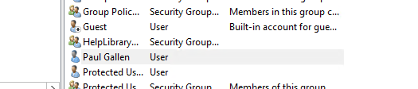

* **Your site collection may not have all the workflow options. If you don’t have all the workflow options available you will need to enable site features

1. Go to your top level site collection
2. Click on the gear > site settings
3. click on Site collection features under Site Collection Administration
4. Go to the bottom of the page and click on Activate next to Workflows

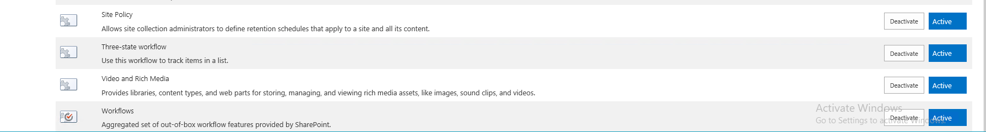

* Helpful Videos and documents for the Assignment:
* Document Library Template
* Assigning a custom template to a document library video
* Workflow/Add template to Document Library and create Collect Signatures workflow

Assignment Details

Given the following scenario, come up with a solution that will work best for the IT Department.

The IT department currently emails a statement of work documents to their manager Paul Gallen each week. They need a site page with a document library to automate the process. The document library will open a new statement of work document and store the statement of work documents. The employee should be able to launch a collect signatures workflow once the document is complete.  The workflow will have its own task list associated with it. The statement of work document located in the Additional Data Files folder. You will need to save this document on your machine.Test your workflow.

** Test your workflow within the document. To do this in word:File>Share>Click on the workflow, click start workflow. ** You must save the document in the document library before you can start the workflow

 What to Screenshot:

* IT team subsite  
    
  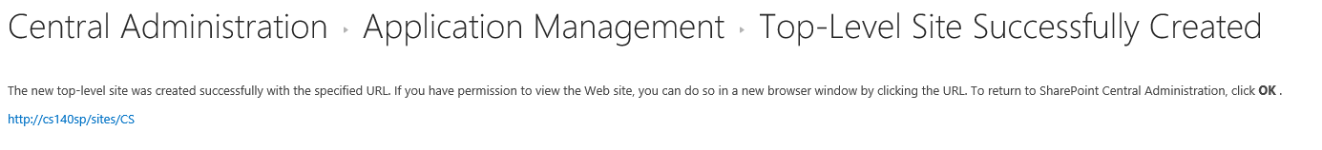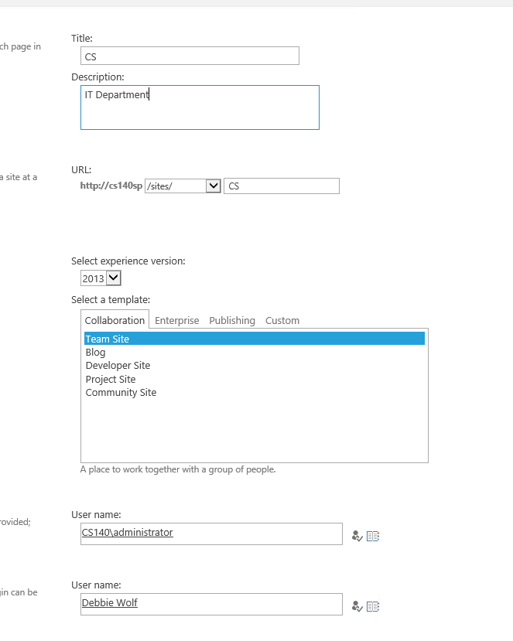  
    
  I created a new site for the Document library and added the needed users for it to work. Also turned on the workflow.
* Statement of work document library  
    
    
    
    
  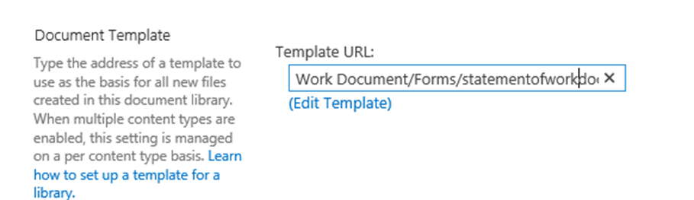  
    
  The template got added to the document library for the statement of work document.
* Statement of work document library Advanced Settings Page

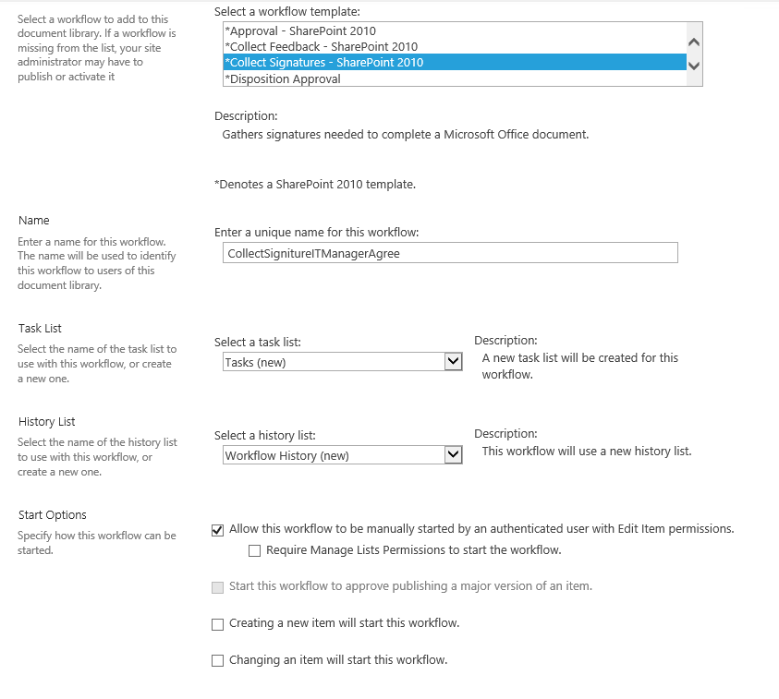  
  
  
  
  
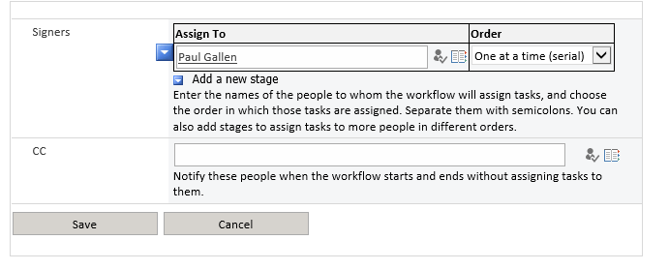

Created the signature workflow and had Paul Gallen as the person that would receive the information

* New Task list showing tasks created from workflow launch.   
    
    
    
  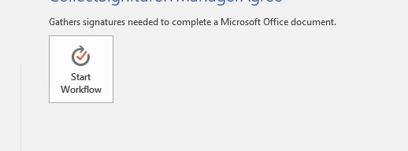  
    
    
  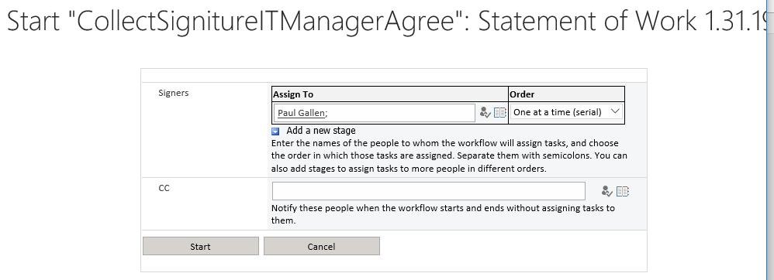

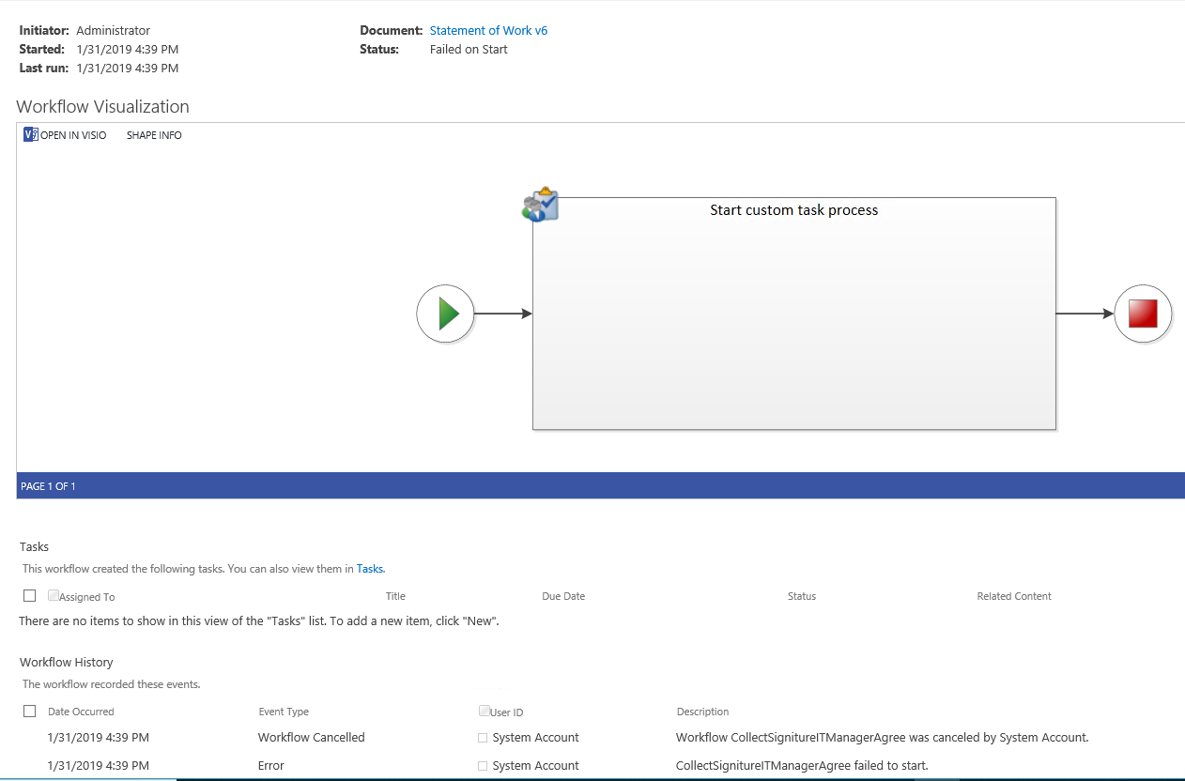II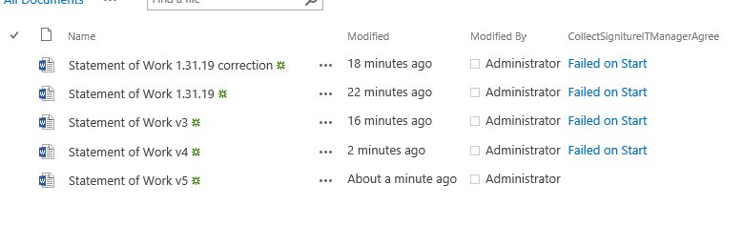  
I followed the sample video in the modules and for some reason I am getting a failed-on-start message. I checked the all over SharePoint, went on the server to check permissions and on the site page. I am thinking it has to do with the administrator or Paul Gallen account having not enough permissions.

* Explain your solution.   
    
  My solution got me almost to the end, but could not figure out how to get over the failed on start message